WORK COMPLETION CERTIFICATE

CERTIFICATE

DECLARATION

ACKNOWLEDGEMENT

CONTENTS

1. SYNOPSIS
1.1 Introduction
1.2 Objective of the Project
1.3 Scope of the Project

2. TECHNOLOGY USED
2.1 Overview of Technologies
2.2 FastAPI Framework
2.3 PyTorch
2.4 HuggingFace Transformers
2.5 Internal Working of FastAPI
2.6 Working of PyTorch
2.7 LSTM Model Internal Working
2.8 Transformer Architecture and RoBERTa Model
2.9 Comparison Between LSTM and Transformer
2.10 Need for Hybrid Model Approach

3. SYSTEM REQUIREMENTS
3.1 Hardware Requirements
3.2 Software Requirements
3.3 Development Environment Setup
3.4 Installation Steps and Execution
3.5 Project Directory Structure

4. TOOLS AND TECHNOLOGIES
4.1 Tools Used
4.2 Technologies Description

5. FEASIBILITY STUDY
5.1 Technical Feasibility
5.2 Economic Feasibility
5.3 Operational Feasibility

6. WORKING OF PROJECT
6.1 System Overview
6.2 System Architecture
6.2.1 Detailed Architecture Flow
6.2.2 Component Interaction Process
6.2.3 Sequence Diagram Description
6.3 Data Processing Flow
6.4 Model Training
6.5 API Functionality
6.6 Detailed API Endpoint Description
6.7 Request and Response Structure
6.8 Error Handling and Validation

7. DATA FLOW DIAGRAM (DFD)
7.1 DFD Introduction
7.2 DFD Level 0 (Context Diagram)
7.3 DFD Level 1
7.4 DFD Level 2
7.5 Process-wise Explanation
7.6 Data Stores

8. ENTITY RELATIONSHIP DIAGRAM (ERD)
8.1 ERD Introduction
8.2 Entities and Attributes
8.3 Relationships
8.4 Database Normalization
8.5 Data Integrity
8.6 Future Database Schema

9. SCREEN SHOTS
9.1 Introduction
9.2 FastAPI Swagger UI
9.3 API Request and Response
9.4 Bulk Request Analysis
9.5 Pretrained Model Output

10. CONCLUSION
10.1 Conclusion
10.2 Advantages of the System
10.3 Limitations of the System
10.4 Comparison with Traditional Methods

11. FUTURE SCOPE
11.1 Future Scope
11.2 Possible Enhancements
11.3 Real-World Applications
11.4 CASE STUDY EXAMPLE
11.5 INDUSTRY USAGE AND FINAL SUMMARY

12. BIBLIOGRAPHY

SYNOPSIS

Introduction
In today’s digital era, businesses receive a massive amount of customer feedback through various platforms such as e-commerce websites, social media, and review systems. Analyzing this feedback manually is time-consuming and inefficient. This is where Sentiment Analysis plays a crucial role.
Sentiment Analysis is a Natural Language Processing (NLP) technique used to determine whether a piece of text expresses positive, negative, or neutral sentiment. This project focuses on building a Sentiment Analysis API that automates this process and provides quick and accurate insights into customer opinions.
The system is developed using FastAPI as the backend framework and PyTorch for implementing deep learning models. It integrates two approaches:
- A custom-trained LSTM model
- A pretrained Cardiff RoBERTa model
This combination ensures both flexibility and high accuracy in sentiment prediction.
The API allows users to send text data and receive sentiment results instantly, making it highly useful for businesses looking to analyze customer feedback in real time.
This project demonstrates how machine learning and modern web frameworks can be combined to build scalable and efficient AI-powered services.

Objective of the Project
The main objective of this project is to develop a robust and efficient Sentiment Analysis API that can analyze customer feedback and classify it into positive, negative, or neutral sentiments.
The key objectives include:
- To automate the process of analyzing textual feedback
- To provide real-time sentiment predictions using an API
- To implement both custom and pretrained machine learning models
- To ensure scalability and performance using FastAPI
- To enable bulk and single text analysis
This project also aims to bridge the gap between machine learning models and real-world applications by deploying them as APIs that can be easily integrated into other systems.

Scope of the Project
The scope of this project is focused on developing a backend system capable of handling sentiment analysis tasks efficiently. It includes:
- Processing customer feedback from various sources
- Performing sentiment classification using deep learning models
- Providing REST API endpoints for interaction
- Supporting both single and bulk input data
- Delivering structured JSON responses
The project can be extended to various domains such as:
- E-commerce product reviews
- Social media sentiment tracking
- Customer service analysis
- Market research
Although the current system focuses on English text and three sentiment classes, it can be further enhanced to support multilingual data and more complex sentiment categories.

TECHNOLOGY USED

Technology Used
This project utilizes a combination of modern backend frameworks and machine learning technologies to build an efficient sentiment analysis system.
1. FastAPI
FastAPI is a high-performance web framework used to build APIs quickly and efficiently. It provides automatic API documentation and supports asynchronous operations, making it ideal for real-time applications.
2. PyTorch
PyTorch is an open-source machine learning library used for building and training deep learning models. In this project, it is used to implement the LSTM model for sentiment classification.
3. LSTM (Long Short-Term Memory)
LSTM is a type of Recurrent Neural Network (RNN) that is effective for processing sequential data such as text. It helps in understanding context and dependencies in sentences.
4. Cardiff RoBERTa Model
This is a pretrained transformer-based model used for sentiment analysis. It provides high accuracy and reduces the need for extensive training.
5. HuggingFace Transformers
This library is used to load and utilize pretrained models like RoBERTa efficiently.
6. Uvicorn
Uvicorn is an ASGI server used to run the FastAPI application.

SYSTEM REQUIREMENTS

System Requirements
To successfully develop and run the Sentiment Analysis API, certain hardware and software requirements must be met.
Hardware Requirements
Processor: Minimum Intel i3 or equivalent
RAM: At least 4 GB (8 GB recommended)
Storage: Minimum 10 GB free space
Internet connection (for downloading pretrained models)
Software Requirements
Operating System: Linux (Ubuntu recommended), Windows, or macOS
Python Version: Python 3.8 or above
Package Manager: pip
Required Libraries
FastAPI
PyTorch
Transformers (HuggingFace)
Uvicorn
NumPy
Pandas
These dependencies are listed in the requirements.txt file and can be installed easily using pip.
Development Environment
Code Editor: VS Code / PyCharm
API Testing Tool: Browser (FastAPI Docs) or Postman

Development Environment Setup
The development environment plays a crucial role in ensuring that the Sentiment Analysis API runs smoothly and efficiently. A properly configured environment allows developers to build, test, and deploy the application without compatibility issues.
To begin with, the system requires Python to be installed, preferably version 3.8 or above. Python serves as the core programming language for both backend development and machine learning implementation. Once Python is installed, the next step is to install pip, which is the package manager used to install all required dependencies.
After setting up Python, a virtual environment is recommended. A virtual environment helps isolate project dependencies from the global system environment, preventing version conflicts. This can be created using the following command:
python3 -m venv venv
source venv/bin/activate
Once the virtual environment is activated, all required libraries can be installed using the requirements.txt file provided in the project.
A code editor such as Visual Studio Code or PyCharm is used to write and manage the project files. These editors provide features like syntax highlighting, debugging tools, and extensions that improve productivity.
Finally, an internet connection is necessary during the initial setup to download dependencies and pretrained models. Once everything is installed, the environment is ready for development and execution.

INSTALLATION AND SETUP PROCESS
Installation Steps and Execution
The installation process of the Sentiment Analysis API is straightforward and involves a series of well-defined steps. These steps ensure that all dependencies are properly installed and the system is ready for execution.
Step 1: System Update
Before installing any software, it is recommended to update the system packages:
sudo apt update
Step 2: Install Python and pip
Install Python and pip using the following command:
sudo apt install python3 python3-pip -y
Step 3: Install Project Dependencies
Navigate to the project directory and install required libraries:
pip3 install -r requirements.txt --break-system-packages
This command installs all necessary frameworks such as FastAPI, PyTorch, and Transformers.
Step 4: Train the Model
Run the training script to train the LSTM model:
PYTHONPATH=. python3 train.py
This step downloads the dataset and generates the trained model file.
Step 5: Run the Server
Start the FastAPI server using:
PYTHONPATH=. python3 -m uvicorn main:app --reload --port 8000
Step 6: Access API
Open the browser and go to:
http://localhost:8000/docs
This will display the interactive API interface.
These steps ensure that the system is correctly installed and ready for use.

Project Directory Structure
Understanding the project structure is essential for maintaining and scaling the application. The Sentiment Analysis API follows a modular structure, which improves readability and organization of the code.
The project directory is organized as follows:
sentiment-analysis/
├── main.py
├── train.py
├── requirements.txt
├── README.md
├── model/
│ ├── sentiment_model.py
│ └── pretrained_model.py
└── routes/
├── sentiment.py
└── pretrained.py

CODE (main.py)

from fastapi import FastAPI
from routes.sentiment import router as sentiment_router
from routes.pretrained import router as pretrained_router

app = FastAPI()

# registers the sentiment routes under /api/v1
app.include_router(sentiment_router, prefix="/api/v1")

# registers the sentiment routes under /api/v1
app.include_router(pretrained_router, prefix="/api/v1")

@app.get("/")
def home():
return {"message": "Hello World"}

@app.get("/health")
def health():
return {"status": "ok"}

Key Components Explanation
1. main.py
This is the entry point of the application. It initializes the FastAPI app and connects all routes.
2. train.py
This file is responsible for training the LSTM model using the dataset.
3. requirements.txt
Contains a list of all dependencies required for the project.
4. model/ directory
This folder contains machine learning logic:
- sentiment_model.py → LSTM model implementation
- pretrained_model.py → RoBERTa model integration
5. routes/ directory
This folder defines API endpoints:
- sentiment.py → LSTM endpoints
- pretrained.py → Pretrained model endpoints
This modular structure ensures that different components of the system are separated, making the project easier to understand, debug, and extend.

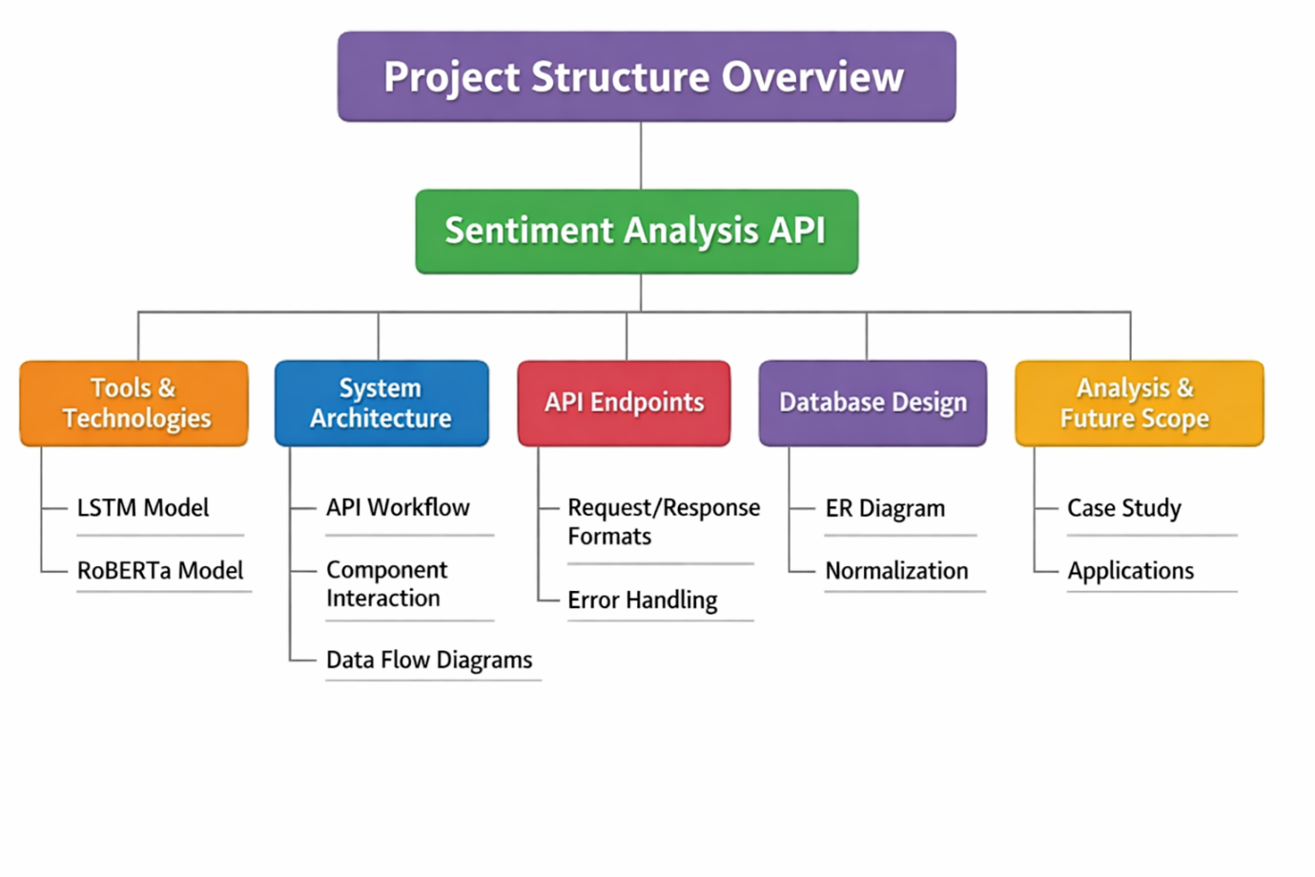

TOOLS AND TECHNOLOGIES (OVERVIEW)

TOOLS AND TECHNOLOGIES
The development of the Sentiment Analysis API involves a combination of backend technologies, machine learning frameworks, and supporting tools. These technologies work together to ensure that the system is efficient, scalable, and capable of handling real-time sentiment analysis tasks.
The primary backend framework used in this project is FastAPI, which enables the creation of high-performance APIs with minimal effort. It provides automatic documentation and supports asynchronous programming, making it suitable for handling multiple requests simultaneously.
For machine learning implementation, PyTorch is used. It is a powerful deep learning framework that allows easy model building, training, and deployment. The project also integrates a pretrained model using the HuggingFace Transformers library, which simplifies the use of advanced NLP models like RoBERTa.
In addition to these, Uvicorn is used as the server to run the FastAPI application. It ensures fast communication between the client and server.
Other tools such as NumPy and Pandas are used for data processing and manipulation during model training.
All these technologies together create a robust system capable of processing customer feedback and delivering accurate sentiment predictions efficiently.

PyTorch and LSTM Model
PyTorch is an open-source deep learning framework widely used for building machine learning models. In this project, it is used to develop a custom LSTM (Long Short-Term Memory) model for sentiment analysis.
LSTM is a type of Recurrent Neural Network (RNN) designed to process sequential data such as text. It is particularly useful in understanding the context of words in a sentence by remembering previous information.
The LSTM model in this project is trained using a dataset (Yelp reviews) to classify text into three categories:
Positive
Negative
Neutral
The training process is handled in the train.py script, where:
Data is loaded and preprocessed
The model is trained on labeled data
The trained model weights are saved for future use
The trained model is stored in the model/ directory and loaded during API runtime for inference.
This approach allows the system to perform sentiment analysis without relying solely on external services, giving more control over customization and performance.

Pretrained Cardiff RoBERTa Model
In addition to the custom LSTM model, this project uses a pretrained transformer model known as Cardiff RoBERTa for sentiment analysis.
RoBERTa (Robustly Optimized BERT Approach) is an advanced NLP model that provides highly accurate results by understanding the context of words in a sentence. It is based on deep learning and transformer architecture.
The Cardiff RoBERTa model used in this project is already trained on large datasets, which eliminates the need for training from scratch. This significantly reduces development time and improves prediction accuracy.
The model is accessed using the HuggingFace Transformers library. When the pretrained endpoint is called for the first time, the model is automatically downloaded and stored locally.
Advantages of using this model:
High accuracy
No training required
Better understanding of complex sentences
Handles contextual meaning effectively
The pretrained model is implemented in the pretrained_model.py file and exposed through API endpoints.

Supporting Tools and Libraries
Apart from the main frameworks and models, several supporting tools and libraries are used to enhance the functionality and performance of the system.
1. Uvicorn
Uvicorn is a lightning-fast ASGI server used to run the FastAPI application. It ensures efficient communication between the client and server.
2. NumPy
NumPy is used for numerical operations and handling arrays. It plays a role in processing data during model training and inference.
3. Pandas
Pandas is used for data manipulation and preprocessing. It helps in organizing and cleaning datasets before training the model.
4. JSON
JSON (JavaScript Object Notation) is used as the data format for API requests and responses. It ensures easy communication between different systems.
5. cURL / Postman
These tools are used for testing API endpoints. They allow developers to send requests and verify responses.
6. VS Code / PyCharm
These are development environments used for writing and managing code efficiently.

FASTAPI INTERNAL WORKING
Internal Working of FastAPI
FastAPI is not just a simple web framework; it is designed to provide high performance and efficiency by leveraging modern Python features such as asynchronous programming. Understanding its internal working helps in appreciating how the Sentiment Analysis API handles multiple requests efficiently.
FastAPI is built on top of Starlette (for web handling) and Pydantic (for data validation). When a request is sent to the API, FastAPI follows a structured pipeline to process it.
First, the incoming request is received by the ASGI server (Uvicorn). The request is then passed to FastAPI, where it is matched with the appropriate route based on the URL and HTTP method. FastAPI automatically validates the input data using Pydantic models. If the input does not meet the expected format, an error response is generated instantly.
Once validated, the request is passed to the corresponding function (endpoint handler). In this project, the handler processes the input text and forwards it to the sentiment analysis model.
FastAPI also supports asynchronous functions (async def), allowing it to handle multiple requests concurrently. This is particularly important for applications like sentiment analysis, where multiple users may send requests simultaneously.
After processing, the response is converted into JSON format and returned to the client.

PYTORCH WORKING MECHANISM
Working of PyTorch
PyTorch is a deep learning framework that provides flexibility and ease of use for building machine learning models. It is widely used for Natural Language Processing tasks due to its dynamic computation graph and strong community support.
In this project, PyTorch is used to implement and train the LSTM model for sentiment analysis. The working of PyTorch revolves around tensors, which are multi-dimensional arrays used to store data.
The process begins with converting text data into numerical form. This is done through tokenization and embedding, where each word is represented as a vector. These vectors are then passed into the LSTM model.
PyTorch uses a concept called a computational graph, where operations are dynamically created during runtime. This allows developers to modify the model easily and debug it efficiently.
During training:
The model makes predictions based on input data
A loss function calculates the error
Backpropagation is used to adjust model weights
An optimizer updates the parameters to minimize the loss
This cycle continues for multiple epochs until the model achieves satisfactory performance.
One of the key advantages of PyTorch is its ability to run computations on GPUs, which significantly speeds up training for large datasets.

LSTM Model Internal Working
LSTM (Long Short-Term Memory) is a type of Recurrent Neural Network (RNN) designed to handle sequential data and capture long-term dependencies. It is particularly useful in Natural Language Processing tasks such as sentiment analysis.
Unlike traditional RNNs, LSTM solves the problem of vanishing gradients by using a special structure called memory cells. Each LSTM unit consists of three main gates:
1. Forget Gate
This gate decides which information from the previous state should be discarded. It ensures that irrelevant information is removed.
2. Input Gate
This gate determines which new information should be added to the memory cell. It updates the cell state based on the current input.
3. Output Gate
This gate controls what information is passed to the next hidden state and ultimately contributes to the output.
The combination of these gates allows the LSTM to maintain important information over long sequences, making it highly effective for text analysis.
In this project, the LSTM model processes sequences of words and learns patterns associated with different sentiments. For example, it can recognize that words like “excellent” or “amazing” indicate positive sentiment, while words like “bad” or “poor” indicate negative sentiment.
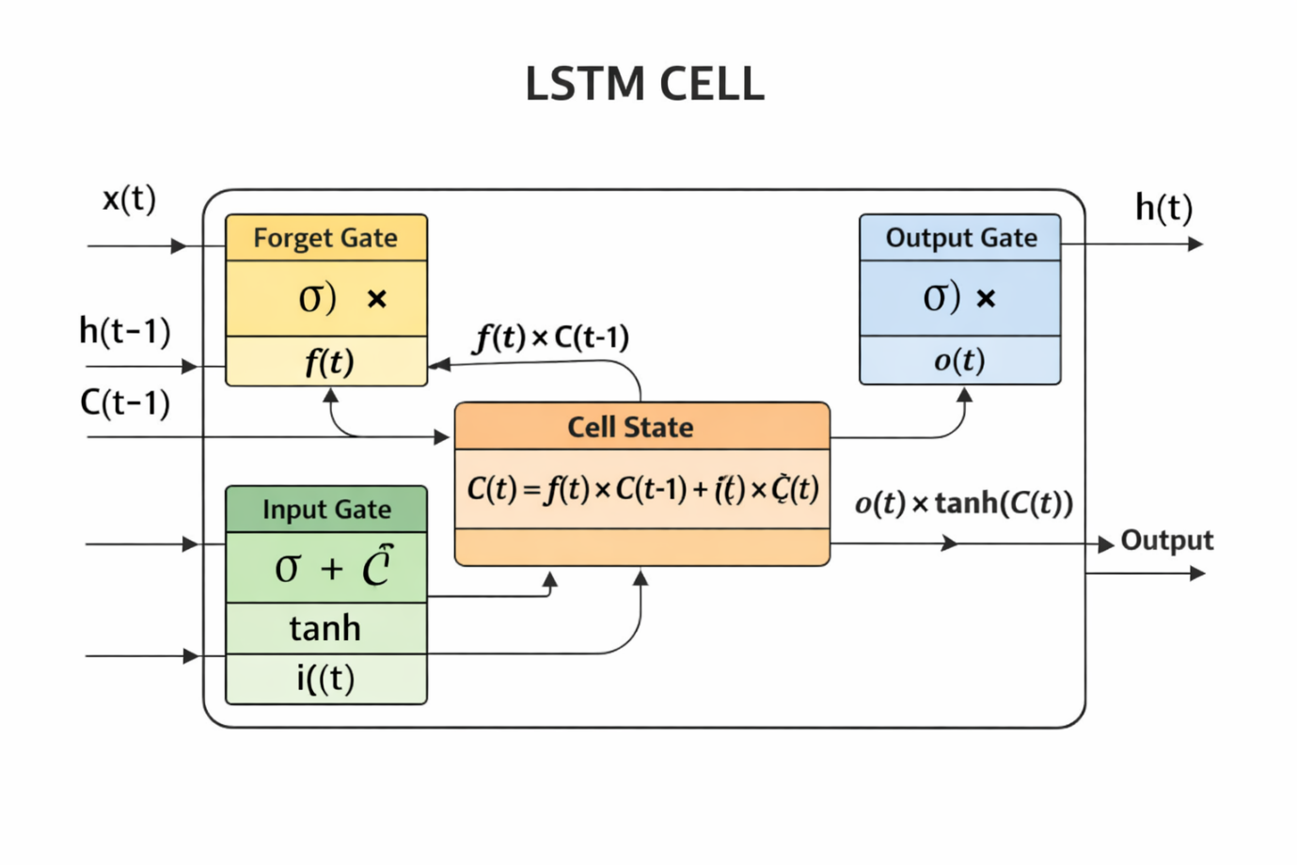

Code Snippet: LSTM Model Architecture Implementation (sentiment_model.py)

class SentimentLSTM(nn.Module):
def __init__(self, vocab_size, embed_dim=64, hidden_dim=128, num_layers=2):
super().__init__()
self.embedding = nn.Embedding(vocab_size, embed_dim, padding_idx=0)
self.lstm = nn.LSTM(embed_dim, hidden_dim, num_layers=num_layers, batch_first=True)
self.fc = nn.Linear(hidden_dim, 3)

def forward(self, x):
emb = self.embedding(x)
out, _ = self.lstm(emb)
pooled = out.mean(dim=1)
return self.fc(pooled)

The above code defines a simple vocabulary class used to convert textual data into numerical format, which is required for processing by machine learning models. The encode function takes input text, splits it into tokens, and maps each word to a corresponding numerical index. If a word is not present in the vocabulary, it is replaced with a special unknown token to ensure consistency. Additionally, the input is padded to a fixed length, allowing the model to process inputs of uniform size. This step is essential for maintaining consistency and improving model performance.

FEASIBILITY STUDY

FEASIBILITY STUDY
A feasibility study is an essential step in any software development project as it helps determine whether the proposed system is practical, achievable, and beneficial. It evaluates different aspects such as technical capability, cost effectiveness, and operational usability before full-scale implementation.
In the context of the Sentiment Analysis API, the feasibility study ensures that the system can be successfully developed using the available tools and technologies while meeting performance and scalability requirements. Since the project involves machine learning models and API development, it is important to analyze whether the system can handle real-time requests, process data efficiently, and deliver accurate results.
The feasibility study is divided into three major categories:
Technical Feasibility – Determines whether the required technology and expertise are available to build the system.
Economic Feasibility – Evaluates the cost involved in development and whether it is justified.
Operational Feasibility – Assesses how well the system will function in a real-world environment and whether users can easily interact with it.
This project has been designed using widely available open-source technologies such as FastAPI, PyTorch, and HuggingFace Transformers, which significantly reduces development complexity and cost. Additionally, the system is lightweight and does not require expensive infrastructure, making it feasible for small-scale as well as large-scale applications.
Overall, the feasibility study confirms that the Sentiment Analysis API is practical, cost-effective, and implementable within the given constraints.

Technical Feasibility
Technical feasibility focuses on evaluating whether the current technology stack and development resources are sufficient to build and deploy the proposed system successfully. For the Sentiment Analysis API, this involves analyzing the availability of tools, frameworks, hardware, and technical expertise required for implementation.
The project uses FastAPI as the backend framework, which is highly efficient and capable of handling asynchronous requests. This ensures that the API can process multiple user requests simultaneously without performance degradation. Additionally, FastAPI provides built-in documentation support, which simplifies testing and integration.
For machine learning, PyTorch is used to build and train the LSTM model. PyTorch is widely adopted in the industry and provides flexibility for developing deep learning models. The integration of a pretrained Cardiff RoBERTa model further enhances the system by providing high accuracy without requiring extensive training.
From a hardware perspective, the system does not demand high-end infrastructure. A standard computer with moderate RAM (4–8 GB) is sufficient for development and testing. For production environments, the system can be deployed on cloud platforms to ensure scalability.
Another important aspect is data availability. The project uses publicly available datasets such as Yelp reviews, which are sufficient for training and testing the model.
Overall, the project is technically feasible because:
All required technologies are open-source and well-documented
The system can run on standard hardware
The models used are proven and reliable
Deployment can be easily managed using modern tools

Economic Feasibility
Economic feasibility evaluates the cost-effectiveness of the project and determines whether the benefits outweigh the expenses involved in development and deployment.
The Sentiment Analysis API project is highly economical due to its reliance on open-source tools and frameworks. Technologies such as FastAPI, PyTorch, and HuggingFace Transformers are freely available, which eliminates the need for purchasing expensive software licenses.
The development cost is minimal since the project does not require specialized hardware or paid services. A standard computer system with internet connectivity is sufficient for building and testing the application. Additionally, the use of pretrained models like Cardiff RoBERTa reduces the time and cost associated with training large models from scratch.
If deployed in a production environment, there may be some operational costs such as:
Cloud hosting services
Storage for models and datasets
Maintenance and updates
However, these costs are relatively low compared to the benefits provided by the system. The API can automate the process of analyzing customer feedback, saving time and human effort. This leads to improved decision-making and better customer satisfaction, which ultimately adds value to businesses.
Furthermore, the scalability of the system ensures that it can grow with increasing demand without requiring significant additional investment.
In conclusion, the project is economically feasible as it provides high value at a low cost, making it suitable for both small businesses and large enterprises.

Operational Feasibility
Operational feasibility focuses on evaluating how effectively the proposed system will function in a real-world environment and whether it will be accepted by its intended users. It examines the usability, reliability, and practicality of the system once it is deployed.
The Sentiment Analysis API is designed to be simple, efficient, and user-friendly. Since it is an API-based system, it does not require users to interact with complex interfaces. Instead, users can send requests using tools like browsers, Postman, or any frontend application, and receive structured responses in JSON format. This makes the system highly adaptable and easy to integrate into existing platforms such as websites, mobile applications, and customer support systems.
One of the key advantages of this system is its automation capability. It eliminates the need for manual analysis of customer feedback, thereby reducing human effort and minimizing errors. Businesses can use this API to analyze large volumes of data in real time, improving their decision-making processes.
The system is also reliable, as it uses tested machine learning models like LSTM and pretrained RoBERTa. These models ensure consistent and accurate sentiment predictions.
From a maintenance perspective, the system is easy to update. New models or improvements can be integrated without affecting the overall structure of the API.
Overall, the project is operationally feasible because:
- It is easy to use and integrate
- It reduces manual workload
- It provides accurate and fast results
- It can be scaled and maintained efficiently

WORKING OF PROJECT

System Overview
The Sentiment Analysis API works as a backend service that processes textual input and returns sentiment predictions. The system is designed to handle both single and bulk inputs, making it flexible for various use cases.
At a high level, the working of the system involves the following steps:
- User Input
The user sends text data (customer feedback) through an API request. This can be done using tools like Postman, cURL, or through a frontend application.
- API Processing (FastAPI)
The request is received by the FastAPI server, which validates the input and routes it to the appropriate endpoint based on the request type.
- Model Selection
Depending on the endpoint, the system chooses either:
  - The custom-trained LSTM model
  - The pretrained Cardiff RoBERTa model
- Text Analysis
The selected model processes the input text and analyzes its sentiment.
- Response Generation
The system generates a structured JSON response containing:
  - Sentiment label (Positive, Negative, Neutral)
  - Confidence scores
  - A summary of the sentiment
- Output Delivery
The response is sent back to the user instantly.

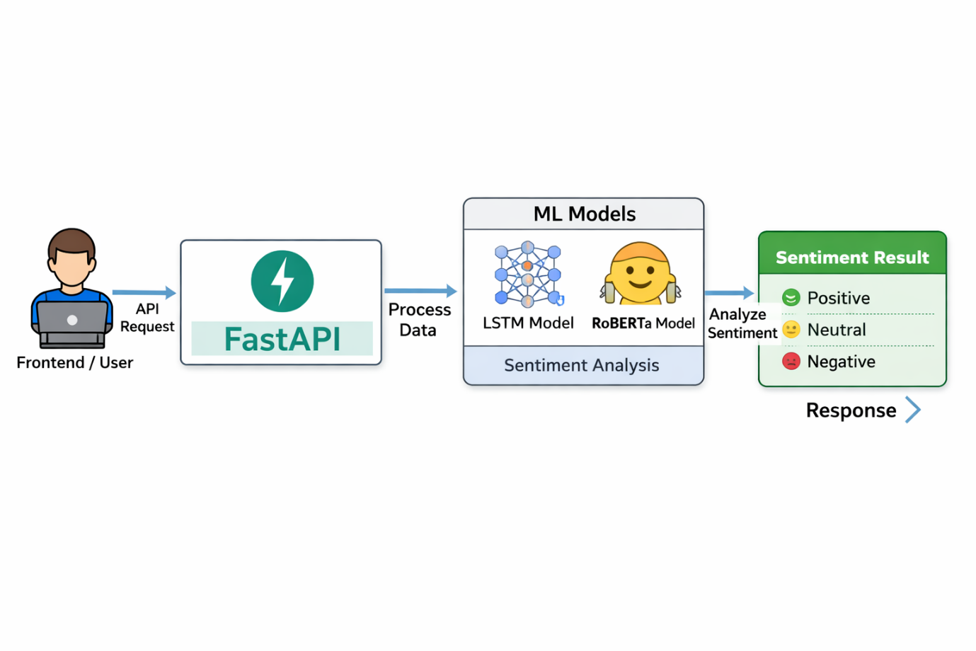

System Architecture
The system architecture of the Sentiment Analysis API is designed to ensure modularity, scalability, and efficient data processing. It follows a layered architecture where each component has a specific role in the overall system.
The architecture consists of the following main components:
1. Client Layer
This layer represents the user or application that interacts with the API. It can be:
- A web application
- A mobile app
- API testing tools like Postman
The client sends requests containing text data to the backend server.
2. API Layer (FastAPI)
This is the core layer of the system. It handles:
- Request validation
- Routing to appropriate endpoints
- Communication between client and models
FastAPI ensures high performance and supports asynchronous operations, making it suitable for handling multiple requests simultaneously.
3. Model Layer
This layer contains the machine learning models used for sentiment analysis:
- LSTM Model (custom trained)
- Pretrained RoBERTa Model
These models process the input text and generate sentiment predictions.
4. Data Layer
This includes:
- Training datasets (e.g., Yelp reviews)
- Model weights and saved files
It ensures that the system has access to the necessary data for training and inference.
5. Response Layer
After processing, the results are formatted into JSON and sent back to the client.

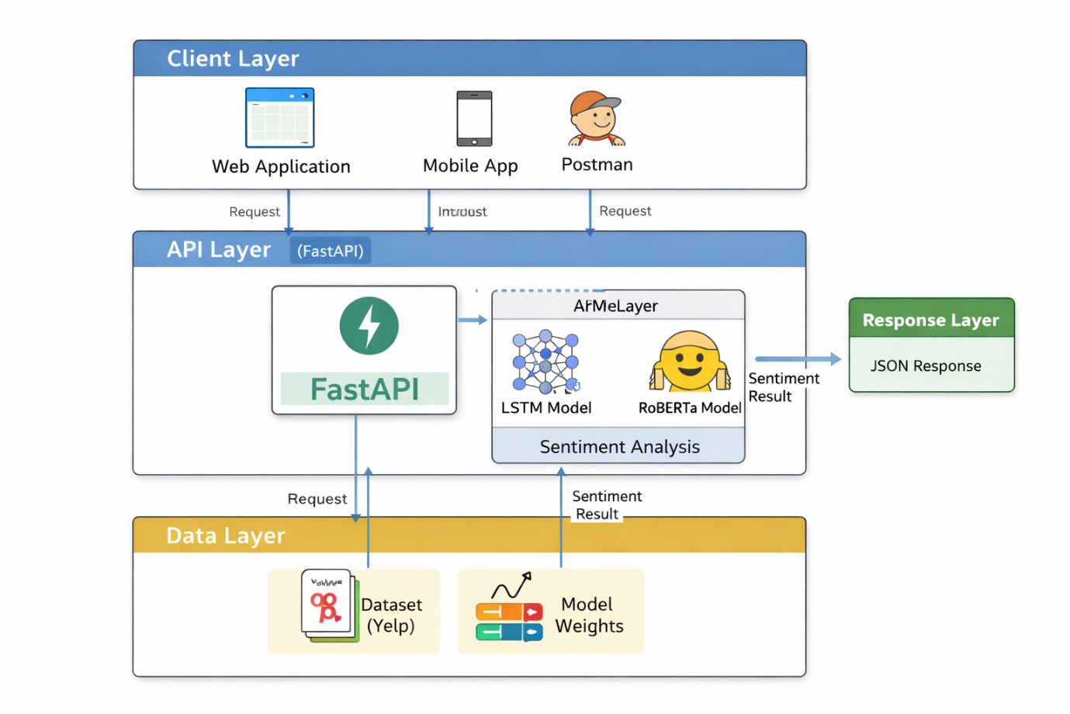

TRANSFORMER AND RoBERTa WORKING
Transformer Architecture and RoBERTa Model
Transformer models represent a major advancement in Natural Language Processing (NLP). Unlike traditional models such as RNNs and LSTMs, transformers do not process text sequentially. Instead, they process the entire input at once, making them faster and more efficient.
The core concept behind transformers is self-attention, which allows the model to understand the relationship between different words in a sentence, regardless of their position. This is especially useful for capturing context in complex sentences.
RoBERTa (Robustly Optimized BERT Approach) is an improved version of the BERT model. It is trained on a large amount of text data and optimized for better performance. In this project, the Cardiff RoBERTa model is used for sentiment analysis.
The working of RoBERTa involves:
Tokenizing the input text
Converting tokens into embeddings
Applying self-attention to understand context
Passing through multiple transformer layers
Generating probability scores for sentiment classes
This model is highly effective in handling nuanced and context-dependent text, such as:
“The product is not bad” (which actually indicates a positive sentiment)

Comparison Between LSTM and Transformer Models
Both LSTM and transformer-based models are used in this project for sentiment analysis, but they differ significantly in their architecture and performance.
1. Processing Style
LSTM processes data sequentially (word by word)
Transformers process all words simultaneously
2. Speed
LSTM is slower due to sequential processing
Transformers are faster due to parallel computation
3. Context Understanding
LSTM captures local dependencies well
Transformers capture global context effectively
4. Accuracy
LSTM provides good accuracy for simpler tasks
Transformers generally provide higher accuracy for complex text
5. Resource Requirement
LSTM requires less computational power
Transformers require more memory and processing power
6. Use in This Project
LSTM is used for custom training and flexibility
RoBERTa is used for high accuracy and advanced understanding
This combination ensures that the system benefits from both approaches, balancing performance and efficiency.

Code Snippet: Text Preprocessing and Vocabulary Encoding (sentiment_model.py)

class SimpleVocab:
def __init__(self):
self.word2idx = {"<PAD>": 0, "<UNK>": 1}

def encode(self, text, max_len=64):
tokens = text.lower().split()[:max_len]
ids = [self.word2idx.get(t, 1) for t in tokens]
ids += [0] * (max_len - len(ids))
return ids

The vocabulary and encoding component is responsible for converting raw text input into a numerical format that can be processed by the machine learning model. Since models cannot understand textual data directly, each word is mapped to a unique index using a vocabulary dictionary. Unknown words are handled using a special token, ensuring robustness. Additionally, input sequences are padded to a fixed length, which maintains consistency in model input size. This preprocessing step is essential for enabling efficient and accurate sentiment prediction.

JUSTIFICATION FOR USING TWO MODELS
Need for Hybrid Model Approach
The use of both LSTM and pretrained RoBERTa models in this project is a strategic decision aimed at balancing performance, flexibility, and accuracy.
The LSTM model is trained specifically for this project using a dataset. This allows customization and gives developers control over how the model behaves. It is lightweight and faster for smaller tasks, making it suitable for quick analysis.
On the other hand, the RoBERTa model is pretrained on massive datasets and has a deep understanding of language. It provides higher accuracy, especially for complex sentences involving sarcasm, negation, or mixed sentiments.
Using both models offers several advantages:
Flexibility to choose between speed and accuracy
Ability to compare model performance
Reduced dependency on a single approach
Better handling of diverse input data
For example:
Simple sentence → LSTM works efficiently
Complex sentence → RoBERTa gives better results
This hybrid approach makes the system more robust and practical for real-world applications.

Text Preprocessing in NLP
Text preprocessing is a crucial step in Natural Language Processing (NLP) as it prepares raw text data for machine learning models. Raw text often contains noise such as punctuation, special characters, and inconsistent formatting, which can negatively impact model performance.
In the Sentiment Analysis API, preprocessing ensures that input text is clean, standardized, and suitable for analysis. This step improves the accuracy and efficiency of both the LSTM and RoBERTa models.
The main preprocessing techniques include:
1. Lowercasing
All text is converted to lowercase to ensure uniformity. For example:
“GOOD Product” → “good product”
2. Tokenization
Text is split into individual words or tokens.
Example:
“The product is great” → [“the”, “product”, “is”, “great”]
3. Removal of Special Characters
Symbols, punctuation, and unnecessary characters are removed to clean the text.
4. Stopword Removal
Common words such as “is”, “the”, and “and” may be removed to focus on meaningful words.
5. Padding and Sequencing
Text is converted into numerical sequences and padded to ensure equal length for model input.
These preprocessing steps are especially important for the LSTM model, as it relies heavily on structured input data.

TOKENIZATION AND WORD EMBEDDINGS
Tokenization and Word Embedding
Tokenization and word embedding are fundamental concepts in NLP that enable machines to understand human language.
Tokenization
Tokenization is the process of breaking down text into smaller units called tokens. These tokens can be words, phrases, or subwords. It is the first step in converting text into a format that machine learning models can process.
There are different types of tokenization:
- Word-level tokenization
- Subword tokenization (used in transformers)
- Sentence tokenization
In this project:
- LSTM uses word-level tokenization
- RoBERTa uses subword tokenization

Word Embedding
Word embedding is the process of converting words into numerical vectors. Since machine learning models cannot understand text directly, each word is represented as a vector in a multi-dimensional space.
These vectors capture semantic meaning. For example:
- “good” and “excellent” will have similar vector representations
- “bad” will be far from “good” in vector space
Common embedding techniques include:
- Word2Vec
- GloVe
- Transformer-based embeddings (used in RoBERTa)
In this project:
- LSTM uses embedding layers in PyTorch
- RoBERTa uses pretrained contextual embeddings
This allows the models to understand the meaning and context of words effectively.

PERFORMANCE METRICS
Model Evaluation Metrics
Evaluating the performance of a sentiment analysis model is essential to ensure its reliability and accuracy. Several metrics are used to measure how well the model performs.
1. Accuracy
Accuracy measures the percentage of correct predictions made by the model.
Formula:
Correct Predictions / Total Predictions
2. Precision
Precision measures how many predicted positive results are actually correct.
3. Recall
Recall measures how many actual positive cases were correctly identified.
4. F1-Score
F1-score is the harmonic mean of precision and recall. It provides a balanced evaluation of the model.
5. Confusion Matrix
A confusion matrix is a table that shows:
- True Positives
- True Negatives
- False Positives
- False Negatives
This helps in understanding where the model is making mistakes.
In this project, these metrics can be used to compare:
- LSTM model performance
- RoBERTa model performance
Using proper evaluation metrics ensures that the system delivers accurate and reliable sentiment predictions.

DATA PROCESSING FLOW
The data processing flow is a critical part of the Sentiment Analysis API, as it defines how raw input text is transformed into meaningful sentiment predictions. This process ensures that the input data is properly handled, cleaned, and analyzed before generating the final output.
The process begins when the user sends a request containing textual data to the API. This data may include customer reviews, feedback comments, or any text that needs sentiment evaluation. Once the request is received, the system performs input validation to ensure that the data is in the correct format.
After validation, the text undergoes preprocessing. This step may include:
- Removing unnecessary characters such as punctuation and special symbols
- Converting text to lowercase for consistency
- Tokenization (splitting text into words or tokens)
- Removing stopwords if required
These preprocessing steps help improve the accuracy of the machine learning models by ensuring that the input data is clean and standardized.
Next, the processed text is passed to the selected model (LSTM or pretrained RoBERTa). The model analyzes the text and assigns probabilities to different sentiment classes (positive, negative, neutral).
Finally, the system formats the output into a structured JSON response, which includes sentiment labels and confidence scores. This response is then sent back to the user.

Model Training
Model training is an essential phase in building the custom sentiment analysis system. In this project, a Long Short-Term Memory (LSTM) model is trained using a labeled dataset to classify text into different sentiment categories.
The training process begins with collecting a dataset. In this case, the Yelp review dataset is used, which contains a large number of customer reviews labeled with sentiment information. This dataset provides a strong foundation for training the model.
Once the dataset is collected, it undergoes preprocessing, which includes cleaning the text, tokenization, and converting words into numerical representations. These numerical representations are required because machine learning models cannot process raw text directly.
The LSTM model is then defined using PyTorch. It consists of layers that help in capturing sequential dependencies in text data. The model is trained using the processed dataset, where it learns to identify patterns associated with different sentiments.
During training:
- The model makes predictions on input data
- The error (loss) is calculated
- The model adjusts its parameters to reduce the error
This process is repeated for multiple iterations (epochs) until the model achieves satisfactory accuracy.
After training, the model is saved as a file (trained_model.pt) so that it can be loaded during API runtime without retraining.
This approach ensures efficient deployment and quick inference during real-time usage.

API FUNCTIONALITY AND ENDPOINTS
The Sentiment Analysis API provides multiple endpoints that allow users to interact with the system and perform sentiment analysis efficiently. These endpoints are designed to handle both single and bulk text inputs, making the system flexible and scalable.
The API includes the following key endpoints:
1. Health Check Endpoint
- GET /health
This endpoint is used to verify whether the API is running successfully. It returns a simple response indicating the system status.
2. LSTM-Based Analysis
- POST /api/v1/analyze
Analyzes a single text input using the LSTM model.
- POST /api/v1/analyze/bulk
Analyzes multiple text inputs in a single request.
3. Pretrained Model Analysis
- POST /api/v1/analyze/pretrained
Uses the Cardiff RoBERTa model for analyzing a single text.
- POST /api/v1/analyze/pretrained/bulk
Handles multiple inputs using the pretrained model.
Each endpoint accepts input in JSON format and returns a structured response containing:
- Sentiment label
- Confidence scores
- Summary of analysis
This design ensures ease of integration with external systems.

DETAILED SYSTEM ARCHITECTURE FLOW
Detailed Architecture Flow
The system architecture of the Sentiment Analysis API can be further understood by analyzing the detailed flow of operations between different components. While the high-level architecture provides an overview, this section explains how each part interacts internally to process a request.
When a user sends a request, it first reaches the FastAPI server through an HTTP call. The server acts as the central controller, responsible for managing all incoming and outgoing communication.
The request is then passed through a validation layer where the input data is checked for correctness. This ensures that the system only processes valid data, reducing the chances of runtime errors.
Once validated, the request is routed to the appropriate endpoint based on the API path. Each endpoint is mapped to a specific function that determines which model should be used for analysis.
After routing, the system forwards the input text to the model layer. Depending on the endpoint, either the LSTM model or the pretrained RoBERTa model is selected. The model processes the text and generates sentiment scores.
The results are then passed to the response formatter, which converts them into a structured JSON format. Finally, the response is sent back to the user.
This layered approach ensures modularity, making the system easy to maintain and extend.

COMPONENT INTERACTION (STEP-BY-STEP)
Component Interaction Process
Understanding how components interact step-by-step is crucial for analyzing system behavior and debugging issues. The Sentiment Analysis API follows a well-defined interaction sequence between its components.
Step 1: User Request
The process begins when the user sends a request containing text data. This request is usually in JSON format and is sent via HTTP POST.
Step 2: API Reception
The FastAPI server receives the request and identifies the appropriate endpoint based on the URL.
Step 3: Input Validation
The input data is validated using built-in mechanisms. If the input is invalid, an error response is returned immediately.
Step 4: Routing Logic
The request is routed to the corresponding function inside the routes directory. This function determines which model to use.
Step 5: Model Invocation
The selected model processes the input text. This includes tokenization, embedding, and prediction.
Step 6: Output Generation
The model generates sentiment scores, which are then converted into a readable format.
Step 7: Response Delivery
The final response is sent back to the user in JSON format.
This step-by-step interaction ensures clarity in system operation and helps developers trace the flow of data.

SEQUENCE DIAGRAM EXPLANATION
Sequence Diagram Description
A sequence diagram is used to represent the order of interactions between different components in a system over time. It provides a dynamic view of how the system processes a request from start to finish.
In the Sentiment Analysis API, the sequence begins with the user sending a request to the FastAPI server. The server receives the request and performs validation. If the input is valid, the request is forwarded to the appropriate endpoint handler.
The endpoint handler then interacts with the model layer, passing the input text for analysis. The model processes the data and returns the prediction results to the API layer.
The API then formats the output and sends it back to the user. Each of these interactions occurs in a specific order, ensuring smooth execution.
Sequence diagrams are particularly useful for:
- Understanding runtime behavior
- Debugging system interactions
- Explaining system flow during presentations

DETAILED ENDPOINT EXPLANATION
Detailed API Endpoint Description
The Sentiment Analysis API provides multiple endpoints, each designed for a specific purpose. While the basic functionality of these endpoints has been discussed earlier, this section provides a more detailed explanation of how each endpoint works internally.
1. Health Check Endpoint
- GET /health
This endpoint is used to verify whether the API is running correctly. It returns a simple response indicating system status. This is useful for monitoring and debugging.
2. Single Text Analysis (LSTM)
- POST /api/v1/analyze
This endpoint accepts a single text input and processes it using the LSTM model. It is ideal for quick sentiment analysis of individual feedback.
3. Bulk Text Analysis (LSTM)
- POST /api/v1/analyze/bulk
This endpoint processes multiple text inputs in a single request. It improves efficiency by reducing the number of API calls.
4. Pretrained Single Text Analysis
- POST /api/v1/analyze/pretrained
Uses the RoBERTa model for more accurate sentiment prediction.
5. Pretrained Bulk Analysis
- POST /api/v1/analyze/pretrained/bulk
Handles multiple inputs using the pretrained model.
Each endpoint is designed to handle specific use cases, ensuring flexibility and scalability of the system.

Code Snippet: API Endpoint Implementation (sentiment.py)

from fastapi import APIRouter
from pydantic import BaseModel
from model.sentiment_model import analyze_sentiment

router = APIRouter()

class FeedbackRequest(BaseModel):
text: str

@router.post("/analyze")
def analyze(req: FeedbackRequest):
return analyze_sentiment(req.text)

class BulkFeedbackRequest(BaseModel):
texts: list[str]

@router.post("/analyze/bulk")
def analyze_bulk(req: BulkFeedbackRequest):
results = [analyze_sentiment(text.strip()) for text in req.texts]

counts = {"Positive": 0, "Neutral": 0, "Negative": 0}
for r in results:
counts[r["label"]] += 1

return {
"results": results,
"summary": {
"total": len(results),
"positive": counts["Positive"],
"neutral": counts["Neutral"],
"negative": counts["Negative"]
}
}

The sentiment.py file implements the API endpoints that handle both single and bulk sentiment analysis requests. It defines structured request models using Pydantic to ensure proper input validation. The single input endpoint processes one text at a time, while the bulk endpoint efficiently handles multiple inputs in a single request. Each input is passed to the analyze_sentiment function, and the results are aggregated to generate a summary of sentiment distribution. This module plays a key role in connecting user requests with the underlying machine learning logic.

REQUEST AND RESPONSE SCHEMA
Request and Response Structure
The Sentiment Analysis API uses JSON as the standard format for communication between the client and server. Understanding the request and response schema is essential for proper integration with other systems.
Request Schema (Single Input)
The client sends a JSON object containing the text to be analyzed:
{
"text": "The service was excellent"
}
Request Schema (Bulk Input)
For multiple inputs, the request contains a list of texts:
{
"texts": [
"Great product",
"Very bad experience"
]
}
Response Schema
The API returns a structured JSON response:
{
"label": "Positive",
"scores": {
"Negative": 5.0,
"Neutral": 10.0,
"Positive": 85.0
},
"summary": "Mostly positive feedback"
}
Bulk Response
Returns a list of such responses corresponding to each input.
This structured format ensures easy parsing and integration with frontend applications.

Code Snippet: Sentiment Prediction and Inference Function (sentiment_model.py)

def analyze_sentiment(text):
vocab, model = _get_model()
ids = vocab.encode(text)
tensor = torch.tensor([ids], dtype=torch.long)

with torch.no_grad():
logits = model(tensor)
probs = torch.softmax(logits, dim=-1).squeeze().numpy()

label = LABELS[int(np.argmax(probs))]
scores = {LABELS[i]: round(float(probs[i]) * 100, 1) for i in range(3)}

return {
"label": label,
"scores": scores,
"summary": generate_summary(label, scores)
}

The analyze_sentiment function serves as the core inference logic of the system, integrating preprocessing, model execution, and output generation. It takes raw text input, converts it into encoded numerical form, and feeds it into the trained LSTM model. The model produces probability scores for each sentiment class, which are then processed using a softmax function. The highest probability determines the final sentiment label, and the results are structured into a JSON response containing label, confidence scores, and a summary. This function acts as the central bridge between the API and the machine learning model.

ERROR HANDLING AND VALIDATION
Error Handling and Input Validation
Error handling and validation are critical components of any API, ensuring that the system behaves predictably even when incorrect input is provided.
In the Sentiment Analysis API, input validation is handled automatically by FastAPI using Pydantic models. When a request is received, the system checks whether the input matches the expected schema. If the input is invalid, an error response is generated without processing the request further.
Common Validation Errors
- Missing required fields
- Incorrect data type (e.g., number instead of text)
- Empty input
Error Response Example
{
"detail": "Invalid input format"
}
Exception Handling
The system also includes exception handling mechanisms to manage runtime errors such as:
- Model loading failure
- Server issues
- Unexpected input cases
Benefits of Error Handling
- Improves system reliability
- Prevents crashes
- Provides meaningful feedback to users
By implementing proper validation and error handling, the API ensures a smooth and robust user experience.

DATA FLOW DIAGRAM (INTRODUCTION)

A Data Flow Diagram (DFD) is a graphical representation used to illustrate how data moves through a system. It helps in understanding the flow of information between different components, processes, and data stores within the system. In the context of the Sentiment Analysis API, the DFD provides a clear visualization of how input data is processed and transformed into meaningful output.
The primary purpose of using a DFD is to simplify complex system operations into easily understandable diagrams. It shows how data enters the system, how it is processed internally, and how the final output is generated. This is particularly useful for developers, analysts, and stakeholders who want to understand the working of the system without going into detailed code-level explanations.
The DFD for this project includes key elements such as:
- External Entities (Users or Clients)
- Processes (API processing, model inference)
- Data Stores (Model files, datasets)
- Data Flow (Movement of data between components)
By using DFDs, we can identify how efficiently the system processes data and whether there are any bottlenecks or redundancies in the workflow.

DFD LEVEL 0 (CONTEXT DIAGRAM)

The Level 0 Data Flow Diagram, also known as the Context Diagram, provides a high-level overview of the entire system. It represents the system as a single process and shows how it interacts with external entities.
In the Sentiment Analysis API, the system is represented as one main process called “Sentiment Analysis System”. The external entity interacting with the system is the User or Client Application, which sends input data and receives output results.
The flow in this diagram is simple:
- The user sends text data (customer feedback) to the system
- The system processes the input
- The system returns sentiment results to the user
This level does not show internal details such as preprocessing or model selection. Instead, it focuses on the overall interaction between the system and the outside world.
The Level 0 DFD is useful for:
- Providing a clear understanding of system boundaries
- Identifying external interactions
- Explaining the system to non-technical stakeholders

DFD LEVEL 1 (DETAILED VIEW)
DFD Level 1
The Level 1 Data Flow Diagram provides a more detailed representation of the system by breaking down the main process into smaller sub-processes. It explains how data flows internally within the Sentiment Analysis API.
In this level, the system is divided into multiple components:
1. Input Handling
The user sends a request containing text data. The API receives and validates the input to ensure correctness.
2. Data Preprocessing
The input text is cleaned and prepared for analysis. This includes tokenization, normalization, and removal of unnecessary elements.
3. Model Selection
Based on the endpoint used, the system selects either:
- LSTM Model
- Pretrained RoBERTa Model
4. Sentiment Analysis
The selected model processes the text and predicts sentiment scores for each category.
5. Response Generation
The results are formatted into JSON and sent back to the user.
6. Data Storage (Optional)
Model weights and datasets are stored for reuse and efficiency.
This level provides a clear understanding of how data moves step-by-step within the system.

DFD LEVEL 2 (DETAILED PROCESS VIEW)
DFD Level 2
The Level 2 Data Flow Diagram (DFD) provides a more detailed breakdown of the processes defined in Level 1. It expands each major process into smaller sub-processes, giving a clearer understanding of how data is handled internally within the Sentiment Analysis API.
At this level, the system is divided into finer operations such as input validation, preprocessing, model execution, and response formatting. Each of these processes plays a crucial role in transforming raw input into meaningful output.
The flow begins with the user sending input text to the system. This input is first passed to the validation module, which checks whether the data is in the correct format. Once validated, the data moves to the preprocessing stage, where it is cleaned and tokenized.
After preprocessing, the system selects the appropriate model based on the API endpoint. The selected model then processes the input and generates sentiment scores.
These scores are passed to the response generation module, which formats them into a structured JSON output. Finally, the response is sent back to the user.
This level of detail helps in understanding the internal workflow and identifying potential areas for optimization.

PROCESS-WISE EXPLANATION OF DFD
Explanation of DFD Processes
Each process in the Data Flow Diagram represents a specific function within the system. Understanding these processes individually helps in analyzing the overall system behavior.
1. Input Process
This process receives the text input from the user. It ensures that the data is captured correctly and passed to the next stage.
2. Validation Process
In this stage, the system checks the input for errors such as missing fields or incorrect formats. Invalid inputs are rejected with appropriate error messages.
3. Preprocessing Process
This process prepares the text for analysis by:
- Cleaning unwanted characters
- Converting text to lowercase
- Tokenizing the text
4. Model Processing
Here, the cleaned text is passed to the selected model (LSTM or RoBERTa). The model analyzes the text and predicts sentiment scores.
5. Response Generation
The output from the model is formatted into a structured JSON response, which includes sentiment labels and confidence scores.
Each of these processes works together to ensure smooth and accurate data transformation within the system.

DATA STORES IN DFD
Data Stores and Their Role
Data stores represent repositories where data is stored for future use. In the Sentiment Analysis API, data stores play an important role in maintaining model files and datasets.
1. Model Storage
The trained LSTM model and pretrained RoBERTa model are stored in the system. These models are loaded during runtime to perform sentiment analysis.
2. Dataset Storage
Datasets used for training, such as Yelp reviews, are stored locally or accessed through external sources. These datasets help in improving model performance.
3. Temporary Data Storage
During processing, intermediate data such as tokenized text and model outputs may be temporarily stored in memory.
4. Future Data Storage (Optional)
If extended, the system can include a database to store:
- User requests
- Sentiment results

ENTITY RELATIONSHIP DIAGRAM

An Entity Relationship Diagram (ERD) is a visual representation used to describe the structure of a system in terms of entities, their attributes, and the relationships between them. It is widely used in database design and system modeling to provide a clear understanding of how different components interact with each other.
In the Sentiment Analysis API project, the ERD helps in identifying the key entities involved in the system, such as user input, models, and output responses. Although this project is primarily API-based and does not rely heavily on a traditional database, the ERD still plays an important role in understanding the logical flow of data and how different elements are connected.
The main purpose of creating an ERD for this system is to:
- Visualize the structure of data within the application
- Identify relationships between different components
- Improve system design and organization
- Provide clarity for future enhancements
The ERD includes entities such as User, API Request, Model, and Response. Each of these entities has specific attributes that define their role in the system.

Entities and Attributes
Entities represent the main objects or components within the system, while attributes define the properties of those entities. In the Sentiment Analysis API, several key entities are involved in processing and analyzing user input.
1. User Entity
This entity represents the client or system that interacts with the API.
Attributes:
- User ID (optional)
- Input Text
- Request Type (single or bulk)
2. API Request Entity
This entity handles incoming requests sent to the system.
Attributes:
- Request ID
- Endpoint Type
- Input Data
- Timestamp
3. Model Entity
This represents the machine learning models used for sentiment analysis.
Attributes:
- Model Name (LSTM / RoBERTa)
- Model Type (trained / pretrained)
- Accuracy
- Model File Path
4. Response Entity
This entity represents the output generated by the system.
Attributes:
- Sentiment Label
- Confidence Scores
- Summary
- Response Time
Each of these entities plays a crucial role in ensuring the smooth functioning of the system. By defining clear attributes, the system becomes more organized and easier to manage.

Relationships Between Entities
Relationships define how different entities in the system are connected and interact with each other. Understanding these relationships is important for designing a well-structured system.
In the Sentiment Analysis API, the relationships between entities can be described as follows:
1. User → API Request
A user sends one or more API requests to the system. This represents a one-to-many relationship, where a single user can generate multiple requests.
2. API Request → Model
Each API request is processed by a specific model. Depending on the endpoint, the request is routed to either the LSTM model or the pretrained RoBERTa model. This is a many-to-one relationship, as multiple requests can be handled by the same model.
3. Model → Response
The model processes the input data and generates a response. This is a one-to-one relationship, where each processed request produces a single output.
4. API Request → Response
Each request corresponds to one response, forming a direct relationship between input and output.
These relationships ensure a structured flow of data within the system. They also help in understanding how different components interact during execution.

DATABASE NORMALIZATION
Database Normalization
Database normalization is a process used to organize data in a structured manner to reduce redundancy and improve data integrity. Although the Sentiment Analysis API does not currently use a full-fledged database, understanding normalization is important for future enhancements where data storage may be required.
Normalization involves dividing a database into smaller tables and defining relationships between them to eliminate duplicate data. It is typically performed in multiple stages called normal forms.
First Normal Form (1NF)
In this stage, all data fields contain atomic values, meaning each field holds only one value. For example, instead of storing multiple texts in one field, each text is stored separately.
Second Normal Form (2NF)
This ensures that all non-key attributes depend on the primary key. It eliminates partial dependencies and ensures proper data organization.
Third Normal Form (3NF)
In this stage, transitive dependencies are removed. This means non-key attributes should not depend on other non-key attributes.
Applying normalization principles ensures:
- Reduced data redundancy
- Improved consistency
- Easier data management
If a database is introduced in this project, normalization will play a key role in structuring tables such as User, Request, and Response efficiently.

DATA INTEGRITY AND CONSISTENCY
Data Integrity
Data integrity refers to the accuracy, consistency, and reliability of data throughout its lifecycle. In the Sentiment Analysis API, maintaining data integrity is essential to ensure correct input processing and reliable output generation.
There are different types of data integrity:
1. Entity Integrity
Ensures that each entity has a unique identifier. For example, each API request can have a unique request ID.
2. Referential Integrity
Maintains consistency between related entities. For instance, a response must always be linked to a valid request.
3. Domain Integrity
Ensures that data values fall within a defined range or format. For example, sentiment labels must only be Positive, Negative, or Neutral.
In this project, data integrity is maintained through:
- Input validation using FastAPI
- Structured JSON formats
- Controlled model outputs
Maintaining data integrity helps prevent errors and ensures that the system produces reliable results. It also improves trust in the system, especially when used in business applications.

FUTURE DATABASE DESIGN
Future Database Schema
Although the current system operates without a persistent database, future versions of the Sentiment Analysis API can include a database for storing and managing data efficiently.
A possible database schema for this project may include the following tables:
1. Users Table
- User ID (Primary Key)
- Name (optional)
- API usage details
2. Requests Table
- Request ID (Primary Key)
- User ID (Foreign Key)
- Input Text
- Timestamp
3. Responses Table
- Response ID (Primary Key)
- Request ID (Foreign Key)
- Sentiment Label
- Confidence Scores
4. Models Table
- Model ID
- Model Name
- Version
- Accuracy
This schema allows efficient storage and retrieval of data. It also enables advanced features such as:
- Tracking user activity
- Analyzing historical sentiment trends
- Generating reports

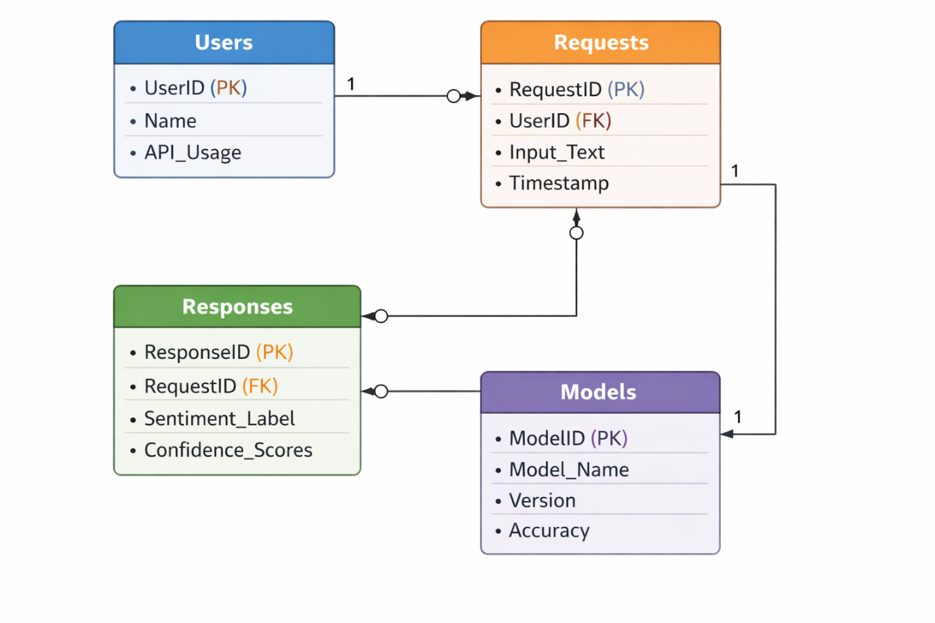

SCREEN SHOTS

The Screenshots section is an important part of the project documentation as it provides visual evidence of the system’s implementation and working. It helps readers understand how the application looks and behaves in a real execution environment. Screenshots make the documentation more practical and easier to follow, especially for users who are not familiar with the technical details.
In the Sentiment Analysis API project, screenshots are used to demonstrate various stages of the system, including API setup, endpoint execution, and output results. Since the project is backend-focused, most screenshots are taken from the FastAPI interactive documentation interface (Swagger UI), terminal outputs, and API testing tools like Postman.
The purpose of including screenshots is to:
- Provide a visual representation of the working system
- Demonstrate successful execution of API endpoints
- Show input and output formats clearly
- Help users replicate the steps easily
.

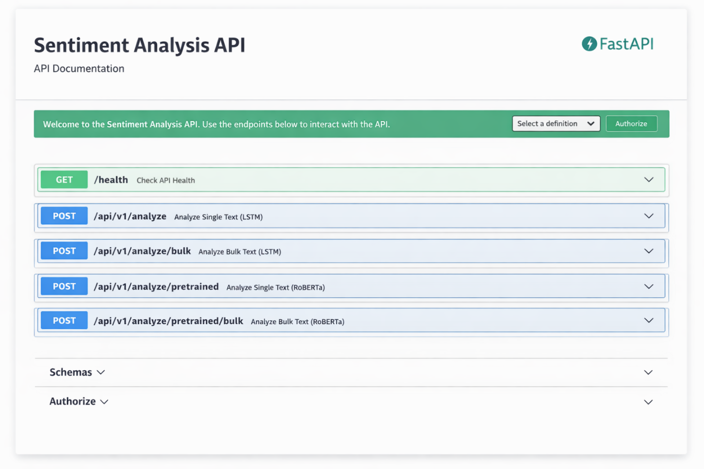

FastAPI Swagger UI
FastAPI provides an interactive API documentation interface known as Swagger UI, which is automatically generated when the server is running. This interface is accessible through the browser at http://localhost:8000/docs.
The Swagger UI allows users to view all available API endpoints, understand their functionality, and test them directly without using external tools. It is one of the most useful features of FastAPI, as it simplifies development, debugging, and demonstration.
In this project, the Swagger UI displays endpoints such as:
- /health
- /api/v1/analyze
- /api/v1/analyze/bulk
- /api/v1/analyze/pretrained
- /api/v1/analyze/pretrained/bulk
Each endpoint includes details such as request type (GET or POST), required input parameters, and example responses. Users can click on an endpoint, enter input data, and execute the request to see real-time results.
This interface is especially useful during testing and presentation, as it eliminates the need for additional software and provides a clear demonstration of API capabilities.

API Request and Response
One of the key aspects of the Sentiment Analysis API is how it handles user input and generates output. This section demonstrates a sample API request and its corresponding response.
The API accepts input in JSON format. For example, a user can send a POST request to analyze a piece of text:
Sample Request:
{
"text": "this product is absolutely amazing"
}
Once the request is processed, the system analyzes the sentiment using the selected model and returns a structured JSON response.
Sample Response:
{
"label": "Positive",
"scores": {
"Negative": 0.0,
"Neutral": 0.0,
"Positive": 100.0
},
"summary": "100.0% positive, 0.0% neutral, 0.0% negative — clearly positive feedback"
}
This response includes:
- The predicted sentiment label
- Confidence scores for each category
- A human-readable summary

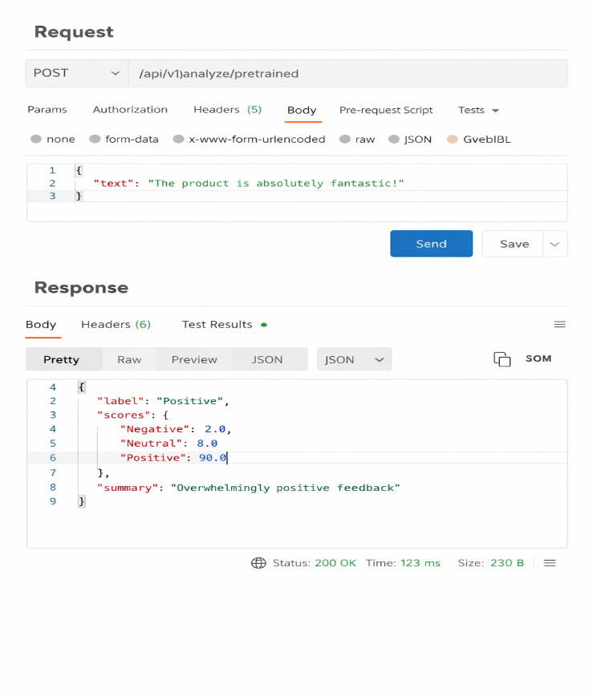

Bulk Sentiment Analysis
In addition to analyzing single text inputs, the Sentiment Analysis API also supports bulk processing. This feature allows users to send multiple pieces of text in a single request, making it highly efficient for analyzing large volumes of customer feedback.
The bulk endpoint (/api/v1/analyze/bulk) accepts a list of text inputs in JSON format. This is particularly useful for businesses that need to process multiple reviews, survey responses, or social media comments at once.
Sample Bulk Request:
{
"texts": [
"The product quality is excellent",
"Delivery was very slow",
"Customer service was okay"
]
}
The API processes each input individually and returns a list of sentiment results. Each result contains the sentiment label, confidence scores, and summary for the corresponding text.
This feature significantly reduces the number of API calls required and improves overall system performance. It also ensures consistency in analysis when dealing with multiple inputs.
Bulk processing is especially beneficial in real-world applications such as:
- Analyzing customer reviews in e-commerce platforms
- Processing survey data
- Monitoring social media feedback

PRETRAINED MODEL OUTPUT SCREENSHOT
The Sentiment Analysis API provides an endpoint that uses a pretrained model (Cardiff RoBERTa) for sentiment analysis. This model is more advanced and generally provides higher accuracy compared to the custom LSTM model.
The endpoint /api/v1/analyze/pretrained allows users to analyze text using this pretrained model. When this endpoint is called for the first time, the model is automatically downloaded and stored locally. Although this initial step may take some time, subsequent requests are processed quickly.
The pretrained model is capable of understanding context more effectively, making it suitable for complex sentences and nuanced feedback.
For example, a sentence like:
“The product is good but the delivery was terrible”
The pretrained model can better capture mixed sentiments and provide a more balanced output.
This feature enhances the flexibility of the API by giving users the option to choose between a custom-trained model and a highly accurate pretrained model.

ADVANTAGES OF THE SYSTEM
Advantages of the Sentiment Analysis API
The Sentiment Analysis API developed in this project offers several advantages that make it a practical and efficient solution for analyzing customer feedback. These advantages highlight the strength of combining machine learning with modern web technologies.
One of the primary advantages of the system is automation. The API eliminates the need for manual analysis of customer feedback, which is often time-consuming and prone to human error. By automating this process, businesses can save time and focus on decision-making.
Another important advantage is real-time processing. The API is capable of analyzing input text and returning results instantly. This is particularly useful for applications such as live customer support and social media monitoring, where timely insights are critical.
The system also provides high accuracy, especially with the inclusion of the pretrained RoBERTa model. This ensures that even complex sentences are analyzed correctly, improving the reliability of the results.
Additionally, the API supports both single and bulk processing, making it flexible for different use cases. It can handle individual feedback as well as large datasets efficiently.
The use of open-source technologies reduces development costs and makes the system accessible to a wide range of users. Furthermore, the modular architecture ensures that the system can be easily updated and extended in the future.
Overall, these advantages make the Sentiment Analysis API a powerful tool for extracting insights from textual data.

LIMITATIONS OF THE SYSTEM
Limitations of the System
Despite its advantages, the Sentiment Analysis API has certain limitations that need to be considered. Identifying these limitations is important for understanding the scope of the system and areas for improvement.
One of the main limitations is the handling of sarcasm and irony. Sentiment analysis models often struggle to correctly interpret sarcastic statements. For example, a sentence like “Great, another delay!” may be interpreted as positive when it is actually negative.
Another limitation is the system’s focus on English language only. The current implementation does not support multilingual input, which restricts its usability in global applications.
The system also relies heavily on training data quality. If the dataset used for training the LSTM model is not diverse or representative, the model’s performance may be affected.
In terms of computational resources, the pretrained RoBERTa model requires more memory and processing power, which may impact performance on low-end systems.
Additionally, the system provides basic sentiment classification (positive, negative, neutral). It does not capture deeper emotions such as anger, joy, or frustration, which could provide more detailed insights.
Understanding these limitations helps in planning future improvements and ensures realistic expectations from the system.

COMPARISON WITH TRADITIONAL METHODS
Comparison with Traditional Methods
Traditional methods of analyzing customer feedback often involve manual review or basic keyword-based techniques. While these methods may work for small datasets, they are inefficient and inaccurate when dealing with large volumes of data.
In manual analysis, human reviewers read and interpret each piece of feedback. This process is time-consuming, expensive, and subject to human bias. It is not scalable for businesses that receive thousands of reviews daily.
Keyword-based methods rely on predefined lists of positive and negative words. While simple to implement, these methods fail to capture context and often produce incorrect results. For example, they may misinterpret phrases like “not bad” or “hardly useful.”
In contrast, the Sentiment Analysis API uses machine learning models that can understand context and patterns in text. The LSTM model captures sequential dependencies, while the RoBERTa model uses advanced transformer architecture to analyze context more effectively.
Key differences include:
- Accuracy: ML models outperform keyword-based methods
- Scalability: API can handle large datasets efficiently
- Automation: Eliminates manual effort
- Context Understanding: Advanced models interpret meaning better
This comparison clearly demonstrates the superiority of modern sentiment analysis techniques over traditional approaches.

CONCLUSION

The Sentiment Analysis API project successfully demonstrates the integration of machine learning models with modern web technologies to create a scalable and efficient system for analyzing customer feedback. The project achieves its primary objective of automating sentiment analysis and providing real-time insights through a well-structured API.
By using FastAPI as the backend framework, the system ensures high performance and easy interaction through RESTful endpoints. The inclusion of both a custom-trained LSTM model and a pretrained Cardiff RoBERTa model provides flexibility and improved accuracy in sentiment prediction. This dual-model approach allows users to choose between faster inference and more context-aware analysis.
The system is capable of handling both single and bulk inputs, making it suitable for a wide range of applications. From analyzing individual customer reviews to processing large datasets, the API proves to be efficient and reliable.
Another key achievement of this project is its simplicity and scalability. The use of open-source tools reduces development costs, while the modular design allows easy updates and future enhancements.
In conclusion, the Sentiment Analysis API is a practical and effective solution for businesses and developers looking to extract meaningful insights from textual data. It highlights the potential of combining Natural Language Processing with web technologies to solve real-world problems.

FUTURE SCOPE

The Sentiment Analysis API developed in this project provides a strong foundation for analyzing customer feedback using machine learning techniques. However, like any system, there is always room for improvement and expansion. The future scope of this project focuses on enhancing its capabilities, improving accuracy, and extending its usability across different domains.
Currently, the system supports three sentiment categories: positive, negative, and neutral. While this is sufficient for basic analysis, future improvements can include more fine-grained sentiment classification such as:
- Very Positive
- Positive
- Neutral
- Negative
- Very Negative
This would allow businesses to gain deeper insights into customer opinions.
Another area of enhancement is multilingual support. At present, the system primarily works with English text. In the future, it can be extended to support multiple languages, enabling global usability and broader application.
The integration of advanced models and continuous learning mechanisms can further improve the system’s performance. By updating models with new data over time, the system can adapt to changing language patterns and trends.
Overall, the future scope of this project is vast, with opportunities to transform it into a comprehensive sentiment analysis platform.

FUTURE SCOPE (ENHANCEMENTS)
Possible Enhancements
There are several enhancements that can be implemented to improve the functionality and efficiency of the Sentiment Analysis API.
1. Real-Time Dashboard
A visual dashboard can be developed to display sentiment analysis results in real time. This would help businesses monitor customer feedback dynamically using charts and graphs.
2. Integration with Frontend Applications
Currently, the project is backend-focused. In the future, it can be integrated with web or mobile applications to provide a complete end-to-end solution.
3. Advanced NLP Features
Additional Natural Language Processing features can be added, such as:
- Topic detection
- Keyword extraction
- Emotion analysis (happy, angry, sad, etc.)
4. Improved Model Accuracy
The system can be enhanced by:
- Training on larger datasets
- Fine-tuning pretrained models
- Using advanced architectures like BERT or GPT-based models
5. Cloud Deployment
Deploying the API on cloud platforms such as AWS, Azure, or Google Cloud can improve scalability and accessibility.
6. Database Integration
Storing user requests and responses in a database can help in tracking historical data and generating analytics reports.
These enhancements would significantly increase the practical usability of the system.

REAL-WORLD APPLICATIONS
REAL-WORLD APPLICATIONS OF SENTIMENT ANALYSIS
Sentiment analysis has become an essential tool in various industries due to its ability to process and interpret large volumes of textual data efficiently. The Sentiment Analysis API developed in this project can be applied in multiple real-world scenarios to derive meaningful insights from customer feedback.
One of the most common applications is in e-commerce platforms, where businesses analyze product reviews to understand customer satisfaction. By identifying positive and negative sentiments, companies can improve product quality and enhance user experience.
Another important application is in social media monitoring. Organizations use sentiment analysis to track public opinion about their brand, products, or services. This helps in identifying trends, managing reputation, and responding to customer concerns promptly.
In the field of customer support, sentiment analysis can be used to prioritize tickets based on urgency. For example, negative feedback can be flagged for immediate attention, ensuring better customer service.
The system can also be applied in market research, where businesses analyze customer opinions to make data-driven decisions. It helps in understanding consumer preferences and predicting market trends.
Additionally, sentiment analysis is useful in financial analysis, where it can be used to evaluate public sentiment about stocks or companies.
These applications demonstrate the versatility and importance of sentiment analysis in modern data-driven environments.

CASE STUDY EXAMPLE
CASE STUDY: E-COMMERCE PRODUCT ANALYSIS
To better understand the practical application of the Sentiment Analysis API, consider a case study involving an e-commerce platform.
Suppose an online store receives thousands of customer reviews daily for its products. Manually analyzing these reviews would be inefficient and time-consuming. By integrating the Sentiment Analysis API, the platform can automate this process.
When a customer submits a review, it is sent to the API, which analyzes the sentiment and returns a result. Positive reviews can be highlighted, while negative reviews can be flagged for further investigation.
For example:
- Review: “The product quality is excellent” → Positive
- Review: “The delivery was delayed” → Negative
The system can aggregate these results to generate insights such as:
- Overall customer satisfaction score
- Common issues (e.g., delivery delays)
- Product performance trends
These insights help businesses:
- Improve product quality
- Enhance customer experience
- Make informed decisions
This case study demonstrates how the API can be used in real-world scenarios to solve practical problems efficiently.

INDUSTRY USAGE AND FINAL SUMMARY
Sentiment analysis is widely used across various industries due to its ability to convert unstructured text into actionable insights. Companies in sectors such as retail, healthcare, finance, and entertainment use sentiment analysis to improve their services and understand customer behavior.
In the retail industry, businesses analyze customer reviews to optimize product offerings. In healthcare, patient feedback is analyzed to improve service quality. In finance, sentiment analysis is used to study market trends and investor opinions.
Large organizations use advanced sentiment analysis systems to process millions of data points daily. These systems help in making strategic decisions and maintaining a competitive advantage.

Final Summary
The Sentiment Analysis API developed in this project successfully demonstrates the integration of machine learning and web technologies to create a practical and scalable solution. The system is capable of analyzing customer feedback efficiently and providing valuable insights in real time.
The use of both LSTM and pretrained RoBERTa models ensures a balance between performance and accuracy. The modular design, ease of use, and scalability make the system suitable for a wide range of applications.
Overall, this project highlights the importance of Natural Language Processing in modern applications and showcases how it can be used to solve real-world problems effectively.

BIBLIOGRAPHY

The development of the Sentiment Analysis API project involved the use of various online resources, documentation, and research materials. These references provided valuable guidance in understanding concepts, implementing technologies, and building the overall system.
The following sources were referred to during the project:
- FastAPI Official Documentation
https://fastapi.tiangolo.com/
Used for understanding API development, routing, and request handling.
- PyTorch Documentation
https://pytorch.org/docs/
Provided guidance on building and training deep learning models.
- HuggingFace Transformers Documentation
https://huggingface.co/docs/
Used for implementing pretrained models like Cardiff RoBERTa.
- Yelp Dataset (HuggingFace Datasets)
https://huggingface.co/datasets
Used for training the LSTM model.
- Uvicorn Documentation
https://www.uvicorn.org/
Helped in understanding server deployment.
- Research Papers on Sentiment Analysis
Various academic papers were referred to for understanding NLP techniques and model architectures.
- Online Tutorials and Technical Blogs
Platforms such as Medium, Towards Data Science, and Stack Overflow were used for troubleshooting and learning best practices.
These resources played a crucial role in successfully completing the project and ensuring its accuracy and effectiveness.

